**EXCEL ASSIGNMENT – 7**

1. Using Insert Function, give examples of any function available in the different dropdowns present in the function library. For example AutoSum, Recently Used, Text, Date & Time, etc.

To insert a function from the Function Library we go through the following steps:

1. On the sheet containing data select the cell for displaying the result.
2. Then click on the Formulastab.

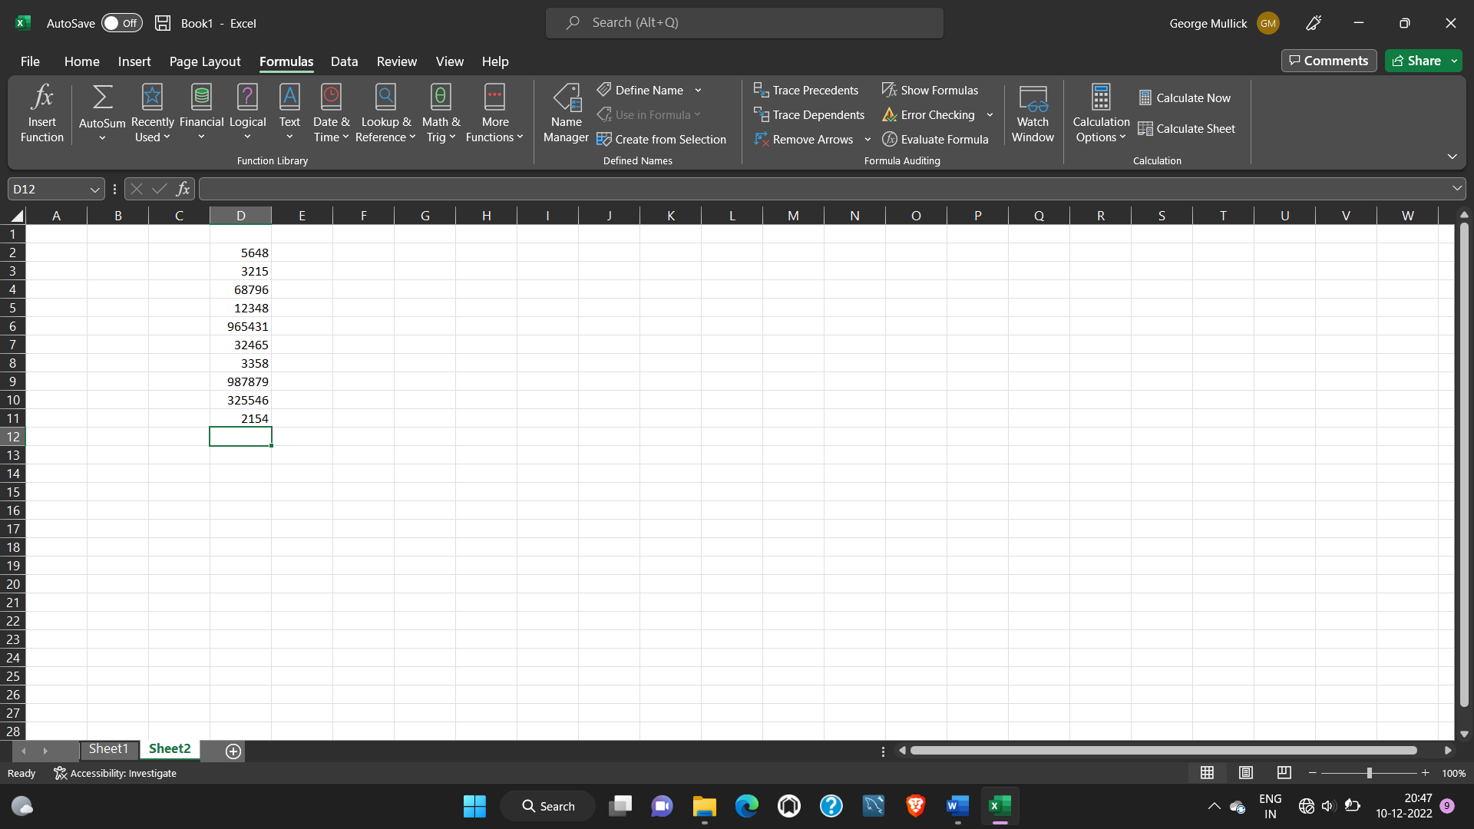

1. Click on Insert function and choose from the drop down list of options available. I’ll choose count function.

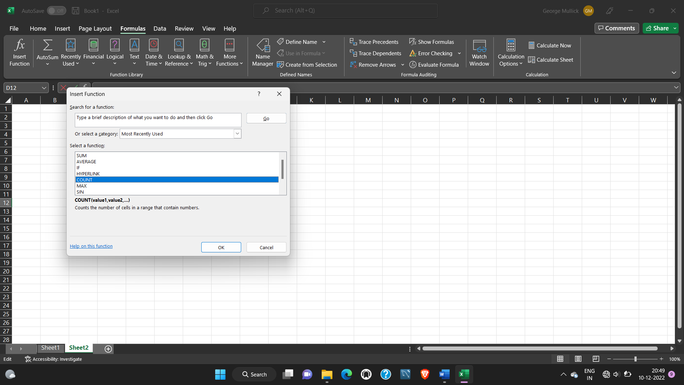

1. The next screen shows us the desired result which is 10 in this case.

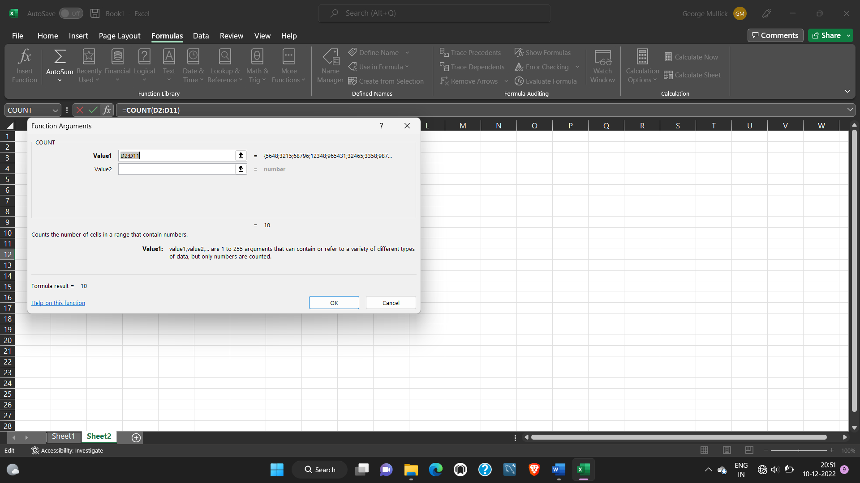

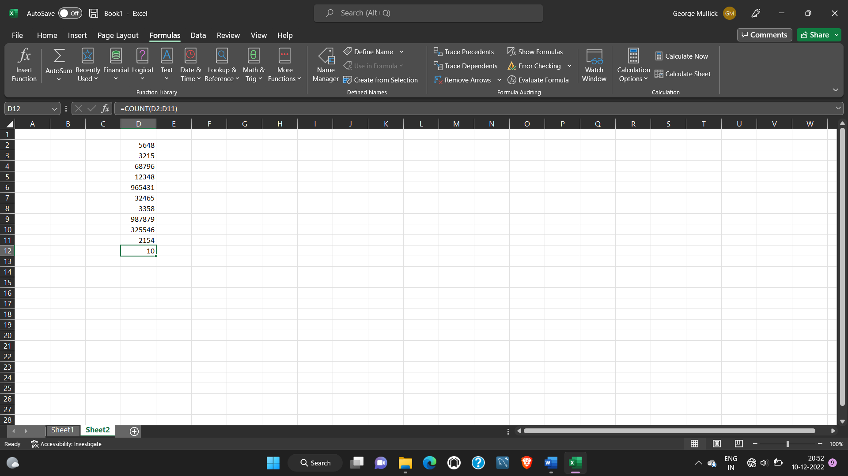

2. What are the different ways you can select columns and rows?

* Select the letter at the top to select the entire column. Or click on any cell in the column and then press Ctrl + Space.
* Select the row number to select the entire row. Or click on any cell in the row and then press Shift + Space.
* To select non-adjacent rows or columns, hold Ctrl and select the row or column numbers.

3. What is AutoFit and why do we use it?

Excel's AutoFit feature is designed to automatically resize cells in a worksheet to accommodate different sized data without having to manually change the column width and row height. AutoFit Column Width - changes the column width to hold the largest value in the column.

4. How can you insert new rows and columns into the existing table?

To insert a row, pick a cell or row that's not the header row, and right-click. To insert a column, pick any cell in the table and right-click. Point to Insert, and pick Table Rows Above to insert a new row, or Table Columns to the Left to insert a new column.

OR we can use the following shortcut keys:

ALT+H 🡪ALT+I 🡪 I

5. How do you hide and unhide columns in excel?

On the Home tab, in the Cells group, click Format. Do one of the following: Under Visibility, click Hide & Unhide, and then click Unhide Rows or Unhide Columns.

6. Create an appropriate table within the worksheet and use different functions available in the AutoSum command.

